**Glamativity Large 4 Pcs Black Abstract Metal Wall Art**

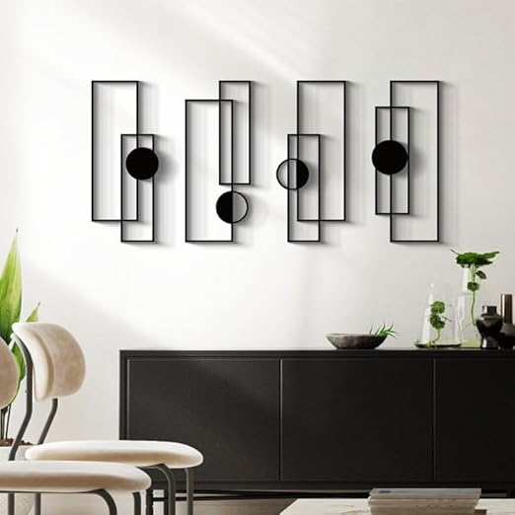Glamativity Large 4 Pcs Black Abstract Metal Wall Art is a bold and contemporary statement piece designed to add a touch of sophistication and elegance to any space. This artwork consists of four panels, each featuring intricate abstract patterns and sharp geometric forms, crafted from durable metal with a sleek black finish. The clean lines and dynamic composition create a sense of depth and movement, making it perfect for modern living rooms, offices, or galleries. The minimalistic black design adds a dramatic, yet refined aesthetic, while the multi-piece structure allows for flexible arrangement, enabling you to customize the display to fit your space. Ideal for those seeking a striking focal point with a luxurious, artistic flair.